**Project 6 Coin Detection**

Name: Forrest Meng Period: 2 Date: 1/23/2019

Did you create the edge matrix? Yes

Did you create the gradient direction matrix? Yes

Did you identify circles? Yes

Below do the following:

1. Paste here 3 clear picture of the initial picture, the picture with the edges, the picture with the original image and the circles you detected drawn in red.
2. Paste the content of your results.txt file
3. Write a succinct journal (max. 2 pages) of what did you attempt during the 2 weeks you worked on this project, what worked, what did not work, what did you debug. Explain your successes and failure in approaching this lab and how did you try to overcome them.

Original Image:

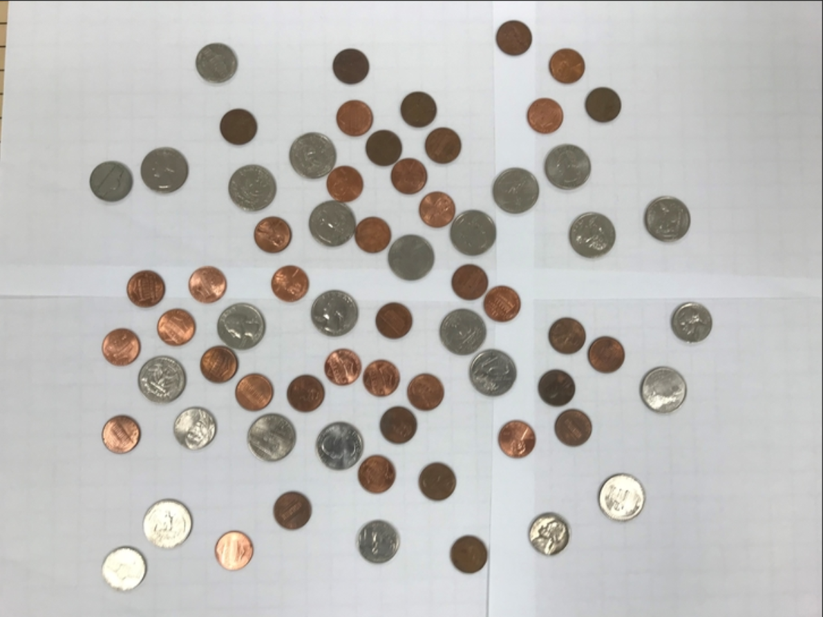

Canny Edge:

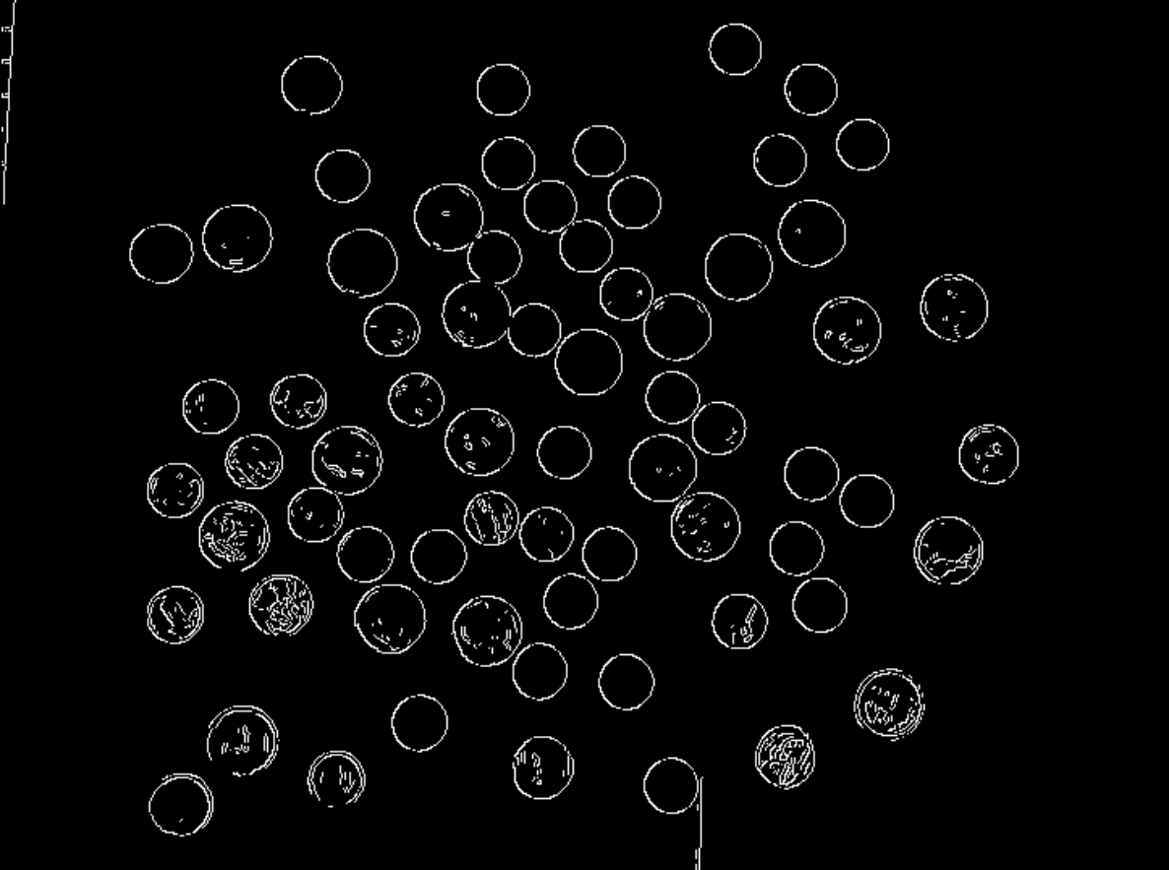

Coin Detection:

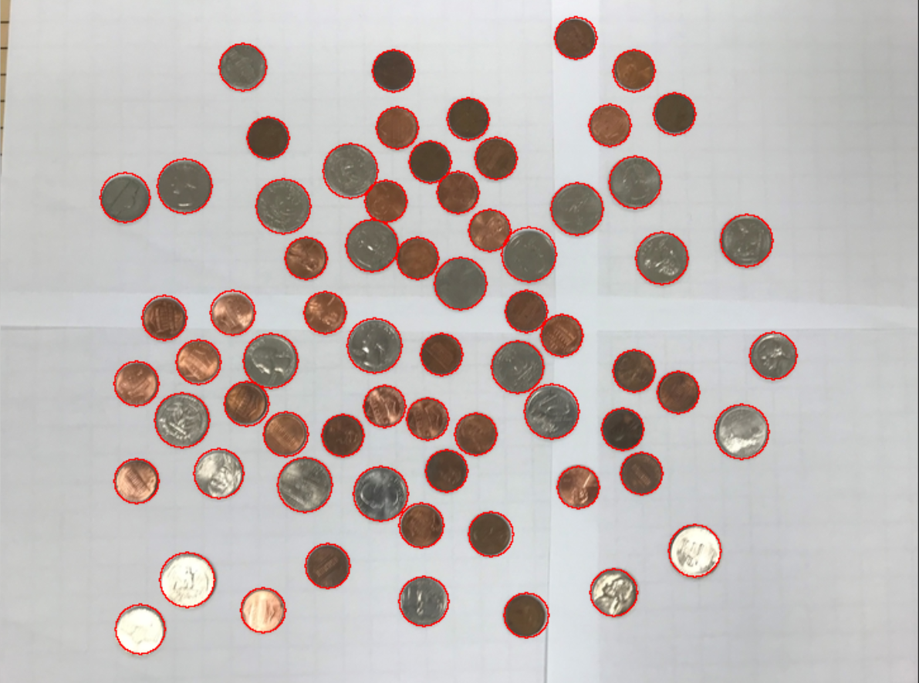

Results:

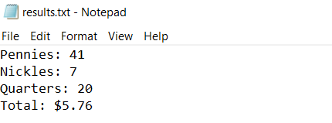

1. Journal:

Approach and Research:

This lab was hard for me to find an approach to complete the Hough Transform algorithm in an effective way and to understand what it did. At first, when searching it up, I had come across a lot of links about linear Hough Transform and many math-related research papers about Hough Transform that were too convoluted to understand without higher math knowledge than BC Calculus. However, after further research, I saw that Hough Transform could be done with circles.

Here are some of the sources I used for research:

<https://en.wikipedia.org/wiki/Circle_Hough_Transform>

<https://www.studocu.com/en/document/universitas-sriwijaya/sistem-jaringan-komputer/practical/coin-recognition-using-circular-hough-transform/6059467/view>

This posed another challenge: how to get the circles to be the right sizes and to use Hough transform to find the center and radius of the detected coins.

I understood after more reading that I needed to draw circles on all the edge pixels to find the highest overlapping point (whitest point) which would be the circle. Since we do not know the radius, we have to test a range of radii. When I was writing this part of my code, some of my previous methods and code structure did not cooperate with my current program writing, so I had to switch some things around such as method headers and variables.

When approaching the lab, I decided to do a circle vote instead of a linear vote for the Hough Transform so that I could get more accurate circle centers. Using the draw circle method written in one of the earlier labs, I got each edge pixel (I created a class called Edge to store each one) and had Hough transform for each one of different radii I calculated to be relative to the size of the image. Once done that, I had a few loops that went through the accumulated gradient matrix of the Hough transform and got the centers of the circles by looking at which points were both above a threshold and not near another possible circle center.

One problem I had at this point were dead loops coming around. I made sure all variables were referenced right and had proper breakpoints so that there would not be dead loops eating up the memory. I also had a problem of choosing the correct radius sizes as well as threshold. Since I was using a scaled down image of the image posted on BlackBoard, I needed to calculate the radius relative to the dimensions of the image. Since I had implemented this, the threshold for the coin values must also change so that it would be high enough to get the most accurate center but also change with image size. My canny edge thresholds for hysteresis were also changed to easily detect edges and get rid of major noise

Once this was done, I had both the circle center pair and the radius size stored into a map. Once these loops were done, I then used the information in the map to plot out the red circles onto the image’s RGB vectors I created before in the Canny Edge detection part. Through the map I also found the averages and standard deviation of the radius sizes, and then calculated the total amount of money through this.

Since the penny and the nickel had similar radii, I had to calculate the standard deviation of the radii sizes and half it to take into account the similar sizes to calculate the money total. Although the count is not exactly correct, it is close enough that each is about correct, give or take 1 or two for the pennies and nickels.